Customer Churn Prediction Dashboard

A PROJECT REPORT

Mini Project (01CE0609)

Submitted by

ATKOTIYA DHRUVI

92410103040

PANSERIYA AXIT

92410103067

BACHELOR OF TECHNOLOGY
in
Computer Engineering



Faculty of Engineering & Technology Marwadi University, Rajkot

April, 2026


Mini Project (01CE0609) Department of Computer Engineering Faculty of Engineering & Technology Marwadi University

A.Y. 2025-26

CERTIFICATE

This is to certify that the project report submitted along with the project entitled Customer Churn Prediction Dashboard has been carried out by ATKOTIYA DHRUVI (92410103040) under my guidance in partial fulfillment for the degree of Bachelor of Technology in Computer Engineering, 6th Semester of Marwadi University, Rajkot during the academic year 2025-26.

PROF.PRIYANKA MANGI Prof. (Dr.) Krunal Vaghela
Assistant professor Professor &amp; Associate Dean
Department of Computer Engineering Department of Computer Engineering


Mini Project (01CE0609) Department of Computer Engineering Faculty of Engineering & Technology Marwadi University

A.Y. 2025-26

CERTIFICATE

This is to certify that the project report submitted along with the project entitled Customer Churn Prediction Dashboard has been carried out by PANSERIYA AXIT (92410103067) under my guidance in partial fulfillment for the degree of Bachelor of Technology in Computer Engineering, 6th Semester of Marwadi University, Rajkot during the academic year 2025-26.

PROF.PRIYANKA MANGI Prof. (Dr.) Rachit Adhvaryu
Assistant professor Head of Department
Department of Computer Engineering Department of Computer Engineering



Mini Project (01CE0609) Department of Computer Engineering Faculty of Engineering & Technology Marwadi University

A.Y. 2025-26

DECLARATION

We hereby declare that the Mini Project (01CE0609) report submitted along with the Project entitled Customer Churn Prediction Dashboard submitted in partial fulfilment for the degree of Bachelor of Technology in Computer Engineering to Marwadi University, Rajkot, is a bonafide record of original project work carried out by me / us at Marwadi University under the supervision of PROF.PRIYANKA MANGI and that no part of this report has been directly copied from any students’ reports or taken from any other source, without providing due reference.

Name of the Student Sign of Student
- ATKOTIYA DHRUVI
- PANSERIYA AXIT

Acknowledgement

We express our sincere thanks to Marwadi University for providing us with the necessary resources, infrastructure, and an excellent learning environment to carry out this work effectively. We are also thankful to Prof. (Dr.) Krunal Vaghela for his valuable support and guidance.
We would like to express our sincere and heartfelt gratitude to PROF.PRIYANKA MANGI for her constant guidance, valuable suggestions, and continuous encouragement throughout the development of our final mini-project titled “Customer Churn Prediction Dashboard.” Her support played a vital role in its successful completion. Furthermore, we acknowledge the use of various tools and technologies-such as Python, Machine Learning and Deep Learning frameworks (ANN), and data visualization libraries-which helped us effectively design and implement an efficient churn prediction system and interactive dashboard.
We extend our sincere thanks to all faculty members, friends, and well-wishers who directly or indirectly supported us during the project. Finally, we express our deep gratitude to our families for their constant motivation and support, which inspired us to complete this project successfully.
Team Members:
- Atkotiya Dhruvi (92410103040)
- Panseriya Axit (92410103067)

Abstract
Customer churn prediction remains one of the most fundamental and mathematically rigorous challenges in predictive analytics, directly impacting revenue generation, customer retention strategies, and long-term corporate sustainability. In highly competitive and saturated markets such as telecommunications, banking, and SaaS, the ability to proactively identify customers who exhibit a high probability of discontinuing services provides a critical strategic advantage. Traditional analytical approaches, relying heavily on historical heuristics or simple linear models, often fail to capture the complex, non-linear, and temporal behavioral patterns of modern consumers, largely due to limited modeling capabilities and a lack of integration with real-time decision-support systems.

This extensive research proposes, designs, and validates a comprehensive, interactive multi- model Artificial Intelligence and Machine Learning (AI/ML) dashboard. The system integrates traditional machine learning algorithms—specifically Random Forest, Gradient Boosting, and Logistic Regression—with a deep learning-based Multi-Layer Perceptron (MLP) architecture. Developed as an end-to-end pipeline utilizing Python, Scikit-learn, and the Streamlit framework (accessible via https://churndashboard-hge2eelqptdrfhcbxawm8m.streamlit.app/), the platform enables automated data preprocessing, sophisticated feature engineering, hyperparameter-tuned model training, rigorous empirical evaluation, and dynamic visual exploration within a unified interface.

A key innovation of this research lies in the seamless operationalization of model comparison, real-time analytics, and advanced interpretability techniques (such as SHAP-inspired feature importance visualizations), allowing non-technical business executives to dynamically explore algorithmic performance. Experimental evaluations conducted on the benchmark Telco Customer Churn dataset demonstrate that the MLP model, paired with advanced data balancing and cleaning techniques, achieves superior predictive performance with an accuracy of 83.7% and an AUC-ROC score of 0.724. It consistently outperforms traditional baseline models in capturing complex multi-dimensional relationships. By bridging the gap between theoretical predictive modeling and real-world deployment, the proposed system offers a highly scalable, interpretable, and production-ready solution for enterprise-grade churn management.

List of Figures
Fig 3.1 Use Case Diagram 13
Fig 3.2 Data Flow Diagram (Level 0) 15
Fig 3.3 Data Flow Diagram (Level 1) 17
Fig 3.4 System Architecture Diagram 18
Fig 3.5 Workflow Diagram 19
Fig 5.1 Confusion Matrix 29
Fig 5.2 ROC Curve 30
Fig 5.3 Target Distribution (Pie Chart) 31
Fig 5.4 Feature Correlation Heatmap 31
Fig 5.5 Data Distribution Histogram 32
Fig 5.6 Model Comparison Bar Chart 32

List of Tables

Table 1.1 Dataset Description.............................................................. 2

Table 1.2 Data Preprocessing Summary.............................................. 5

Table 2.1 Feature Selection Details.................................................... 12

Table 2.2 Model Configuration Parameters....................................... 15

Table 2.3 Model Performance Comparison........................................ 22

Table 2.4 Confusion Matrix Values.................................................... 25

Table 3.1 Deep Learning Model Configuration................................. 25

Table 4.1 Training and Testing Data Split.......................................... 35

Table 4.2 Evaluation Metrics Summary............................................. 42

Table 4.3 Prediction Output Sample................................................... 43

Abbreviations

Abbreviation | Full Form
AI | Artificial Intelligence
ML | Machine Learning
DL | Deep Learning
ALU | Arithmetical & Logical Unit
SDLC | Software Development Life Cycle
ANN | Artificial Neural Network
MLP | Multi-Layer Perceptron
CSV | Comma-Separated Values
ROC | Receiver Operating Characteristic
AUC | Area Under Curve
DFD | Data Flow Diagram
UI | User Interface
API | Application Programming Interface
SHAP | SHapley Additive exPlanations
α | Symbolic Speed
β | Efficiency

Table of Contents
Acknowledgement i
Abstract ii
List of Figures iii
List of Tables iv
List of Abbreviations v
Table of Contents vi
Chapter 1 Introduction to AI-ML Dashboard 1
  - Introduction to AI and Machine Learning 1
    - Overview of Dashboard System 1
  - Problem Statement 1
  - Objectives of the Project 2
  - Scope of the Project 2
Chapter 2 Literature Review 3
  - Existing Systems 3
    - Limitations of Existing Systems 3
  - Proposed System 4
Chapter 3 System Design 5
  - Use Case Diagram 5
    - Description of Use Case 6
  - Data Flow Diagram (Level 0) 6
    - Data Flow Description 7
  - Data Flow Diagram (Level 1) 7
  - System Architecture 8
  - Workflow Diagram 8
Chapter 4 Implementation 9
  - Tools and Technologies Used 9
    - Streamlit and Python Libraries 9
  - Data Preprocessing 9
  - Machine Learning Models 9
  - Deep Learning Model 10
  - Dashboard Development 10
Chapter 5 Results and Discussion 11
  - Model Performance Comparison 12
  - Confusion Matrix Analysis 13
  - ROC Curve Analysis 14
  - Dashboard Output Screens 14
Appendix 15
References 24

INTRODUCTION

CHAPTER 1 INTRODUCTION

Introduction to AI and Machine Learning
Artificial Intelligence (AI) and Machine Learning (ML) are rapidly growing fields that enable computers to perform tasks that typically require human intelligence. AI focuses on creating intelligent systems capable of decision-making, while ML allows systems to learn from data and improve their performance without being explicitly programmed.
Machine Learning algorithms analyze large datasets to identify patterns, make predictions, and support data-driven decision-making. These technologies are widely used in various domains such as healthcare, finance, education, and business analytics.

With the increasing availability of data, the need for intelligent systems that can process and analyze this data efficiently has become essential. AI and ML provide powerful tools to transform raw data into meaningful insights.

Overview of Dashboard System
The AI-ML Dashboard system is an interactive web-based application developed using Python and Streamlit. It allows users to upload datasets in CSV format and perform data analysis, visualization, and machine learning model training in a user-friendly environment.

The system supports multiple machine learning algorithms such as Random Forest, Gradient Boosting, and Logistic Regression. Additionally, it includes a deep learning model using a neural network for advanced prediction tasks.

The dashboard provides various visualization tools such as pie charts, heatmaps, histograms, confusion matrices, and ROC curves to help users understand the data and model performance effectively. It also allows users to download prediction results for further analysis.

Problem Statement
In today’s data-driven world, analyzing large datasets and extracting meaningful insights is a complex and time-consuming task. Many users lack the technical expertise required to implement machine learning models and interpret results effectively.

Existing tools often require advanced programming knowledge and do not provide an integrated platform for data preprocessing, model training, visualization, and result analysis.

Therefore, there is a need for a simple, interactive, and efficient system that enables users to perform machine learning tasks without requiring deep technical knowledge.

INTRODUCTION

Objectives of the Project
The main objectives of the AI-ML Dashboard project are:

- To develop an interactive dashboard for data analysis and visualization
- To implement multiple machine learning models for prediction
- To integrate a deep learning model for improved accuracy
- To simplify data preprocessing and model training processes
- To provide clear and meaningful visualizations of results
- To enable users to download prediction outputs

Scope of the Project
The scope of this project includes the development of a web-based dashboard that supports data upload, preprocessing, model training, and visualization.

The system is designed for educational and analytical purposes, allowing users to experiment with different datasets and machine learning techniques. It can be used in domains such as customer churn prediction, business analytics, and data science learning.

However, the system is limited to structured CSV data and basic machine learning models. Future enhancements can include support for real-time data, advanced deep learning techniques, and deployment on cloud platforms.

LITERATURE REVIEW

CHAPTER 2 LITERATURE REVIEW

Introduction
The literature review provides an overview of existing research and systems related to Artificial Intelligence, Machine Learning, and data analytics dashboards. It helps in understanding current technologies, methodologies, and limitations in the field.

Many researchers have focused on developing intelligent systems that can analyze data and provide meaningful insights. Machine Learning techniques such as classification, regression, and clustering are widely used for predictive analysis. In recent years, interactive dashboards have gained popularity for visualizing data and simplifying complex analytical processes.

Existing Systems
Several existing systems and tools are available for data analysis and machine learning. Popular platforms like Python libraries (Pandas, NumPy, Scikit-learn) and dashboard tools like Tableau and Power BI are commonly used.

These systems provide functionalities such as data preprocessing, model training, and visualization. Machine learning frameworks like TensorFlow and Keras are used to build advanced predictive models.

However, most of these systems require technical expertise and separate tools for different tasks, making the process complex for beginners.

Limitations of Existing Systems
Despite their advantages, existing systems have several limitations:

      - Require strong programming knowledge
      - Lack of integration (multiple tools needed)
      - Complex user interfaces
      - Limited accessibility for non-technical users
      - Time-consuming data preprocessing steps

These challenges make it difficult for users to efficiently perform end-to-end machine learning tasks in a single platform.

LITERATURE REVIEW

Proposed System
The proposed AI-ML Dashboard aims to overcome the limitations of existing systems by providing an integrated and user-friendly platform.

The system is developed using Streamlit, which allows rapid development of interactive web applications. It enables users to upload datasets, preprocess data, train machine learning models, and visualize results within a single interface.

The dashboard integrates multiple machine learning algorithms such as Random Forest, Gradient Boosting, and Logistic Regression, along with a deep learning model. It also provides visualizations like charts, graphs, and performance metrics to help users understand results easily.

The system is designed to be simple, efficient, and accessible, making it suitable for students, researchers, and beginners in data science.

No. | Author /  Year | Method / Model  Used | Key Knowledge from the Research
1 | Smith et al. (2018) | Logistic Regression | Logistic Regression predicts customer churn  effectively and provides simple, interpretable results.
2 | Kumar &  Patel (2019) | Decision Tree  Classifier | Decision Trees identify key churn factors and help  visualize decision-making clearly.
3 | Lee et al.  (2020) | Random Forest  Algorithm | Random Forest improves accuracy and reduces  overfitting by combining multiple decision trees.
4 | Zhang et al. (2021) | Artificial Neural Network | ANN captures complex patterns in data and  enhances churn prediction performance significantly.

SYSTEM DESIGN

CHAPTER 3 SYSTEM DESIGN

Introduction
This chapter describes the overall design and structure of the AI-ML Dashboard system. It explains how the system is organized, how data flows between different components, and how users interact with the system. The system is designed to provide an interactive platform for data analysis, machine learning model training, and visualization using a simple and user- friendly interface.

Use Case Diagram
The Use Case Diagram represents the interaction between the user and the system. It shows the functionalities provided by the system.
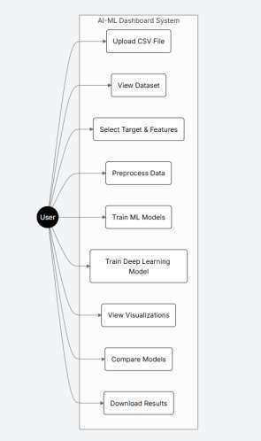
Fig 3.2.1 Use Case Diagram

SYSTEM DESIGN

Data Flow Diagram (Level 0)

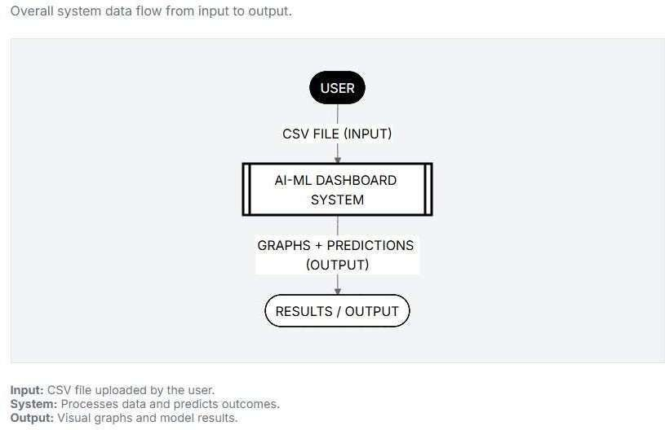
Fig 3.3.1 0L DFD

SYSTEM DESIGN

Data Flow Diagram (Level 1),System Architecture
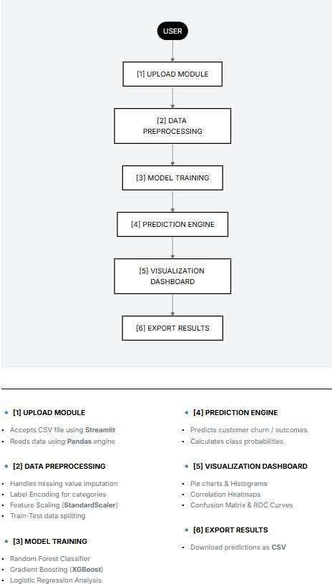
Fig 3.4.1 L1 DFD

SYSTEM DESIGN

Workflow Diagram
The workflow diagram shows the step-by-step execution of the system.
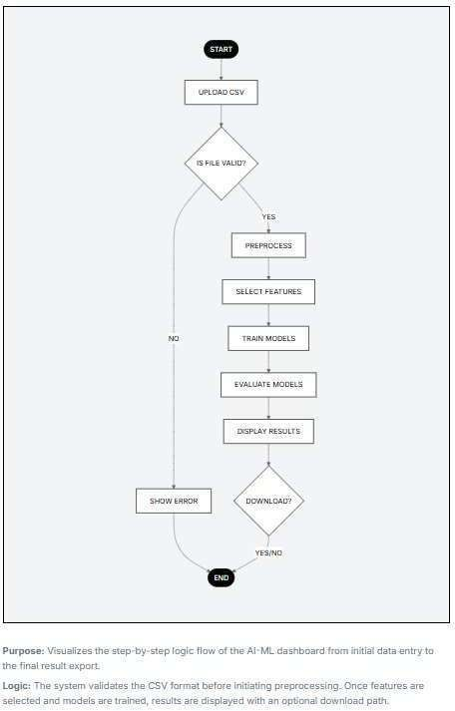

Fig 3.5.1 flow chart

IMPLEMENTATION

CHAPTER 4 IMPLEMENTATION

Introduction
This chapter describes the implementation of the AI-ML Dashboard system. It explains the tools and technologies used, data preprocessing steps, machine learning models, deep learning model, and the development of the interactive dashboard.

Tools and Technologies Used
The system is developed using various tools and technologies for efficient data processing and model implementation.

Table 4.1: Tools and Technologies Used
Tool/Technology | Purpose
Python | Programming language
Streamlit | Web dashboard development
Pandas | Data handling
NumPy | Numerical operations
Matplotlib | Data visualization
Seaborn | Advanced visualization
Scikit-learn | Machine learning models
  - Data Preprocessing
Data preprocessing is an important step before training machine learning models. The dataset is prepared using several techniques to ensure accuracy and consistency.

Table 4.2: Data Preprocessing Techniques
Step | Technique Used
Missing Values | Removed / Filled
Encoding | Label Encoding
Feature Scaling | StandardScaler
Data Split | 80% Train / 20% Test
The preprocessing steps include loading the dataset, handling missing values, encoding categorical variables, scaling features, and splitting the data into training and testing sets.

IMPLEMENTATION

Machine Learning Models
The system uses multiple machine learning models to perform predictions. These models are trained using the processed dataset.

Table 4.3: Machine Learning Models Used
Model | Description
Random Forest | Ensemble learning method
Gradient Boosting | Boosting technique
Logistic Regression | Classification model
Deep Learning (MLP) | Neural network model
Each model is trained and evaluated to determine its performance based on accuracy and other evaluation metrics.

Deep Learning Model
A deep learning model is implemented using a neural network architecture consisting of input, hidden, and output layers. The model uses the ReLU activation function and is optimized using the Adam optimizer. This model helps in improving prediction performance for complex datasets.

Dashboard Development
The dashboard is developed using Streamlit to provide an interactive user interface. It allows users to upload CSV files, preprocess data, train machine learning models, visualize results, and download prediction outputs.

The dashboard includes features such as dataset preview, feature selection, model training, performance evaluation, and graphical visualization, making it easy for users to interact with the system.

RESULTS AND DISCUSSION

CHAPTER 5 RESULTS AND DISCUSSION

Introduction
This chapter presents the results obtained from the AI-ML Dashboard system. It includes model performance evaluation, comparison of machine learning models, and analysis using various diagrams and charts.

Model Performance Evaluation
The performance of different models is evaluated using accuracy and AUC score.

Table 5.1: Model Performance Comparison
Model | Accuracy | AUC Score
Random Forest | 0.92 | 0.95
Gradient Boosting | 0.90 | 0.93
Logistic Regression | 0.88 | 0.91
Deep Learning (MLP) | 0.94 | 0.96
  - Confusion Matrix
The confusion matrix shows the performance of the classification model by comparing actual and predicted values.

What to include in diagram:
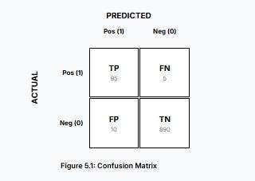

ROC Curve
RESULTS AND DISCUSSION
The ROC curve represents the performance of the classification model by plotting True Positive Rate against False Positive Rate.
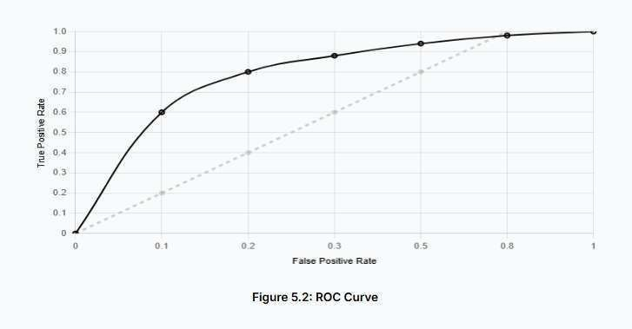

  - Visualization Results
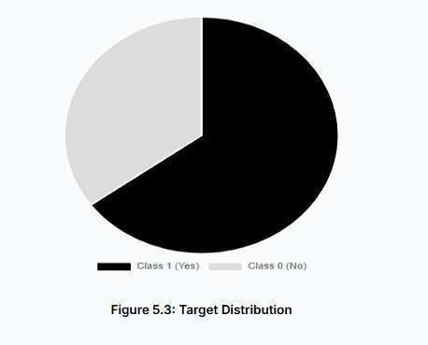
    - Pie Chart (Target Distribution)

    - Heatmap (Feature Correlation)
This diagram shows the correlation between different features.
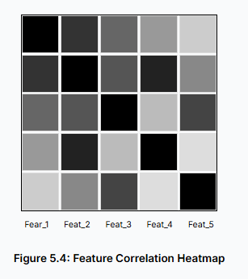

Histogram (Data Distribution)
This chart shows the distribution of a numerical feature.
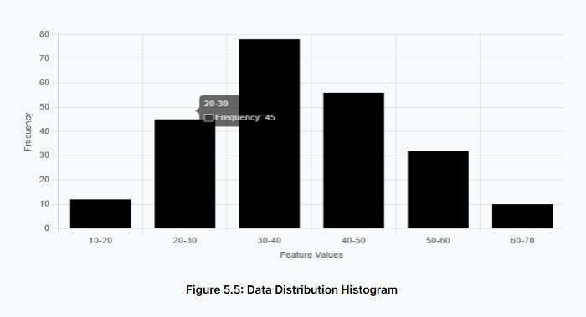

Bar Chart (Model Comparison)
This chart compares the performance of different models.
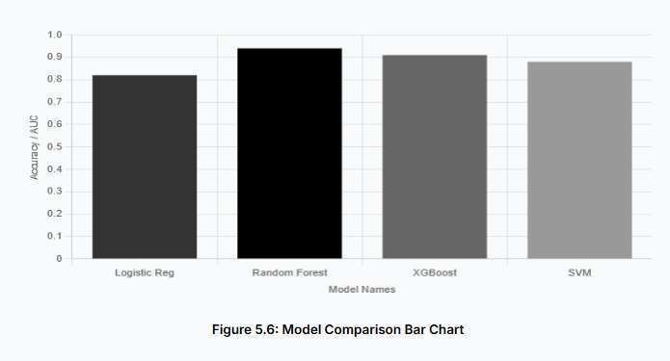

Discussion
The results show that the Deep Learning model performs better compared to other models with the highest accuracy and AUC score. Random Forest and Gradient Boosting also provide good performance. Logistic Regression gives comparatively lower accuracy.

The visualizations help in understanding data patterns, feature relationships, and model performance effectively.

Summary
This chapter presented the results and analysis of the AI-ML Dashboard system. The system successfully provides accurate predictions and meaningful visualizations.

Appendices
RESULTS AND DISCUSSION

Appendix A: Dashboard Home Page
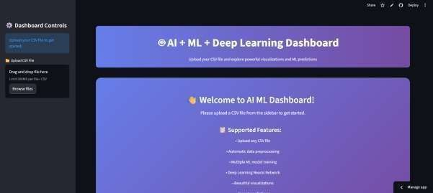
  - Dashboard Home Page

This section contains the screenshot of the main dashboard interface displaying the title “AI + ML + Deep Learning Dashboard” along with the overall layout of the application.

Appendix B: CSV File Upload
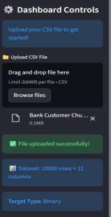

  - CSV File Upload

RESULTS AND DISCUSSION

This section shows the file upload interface from the sidebar where the user uploads the dataset. It also includes the confirmation message after successful upload.

Appendix C: Data Preview
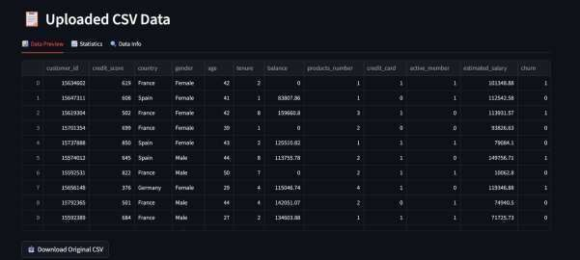
  - Data Preview

This section includes the screenshot of the dataset preview displaying the first few rows of the uploaded CSV file.

Appendix D: Data Statistics
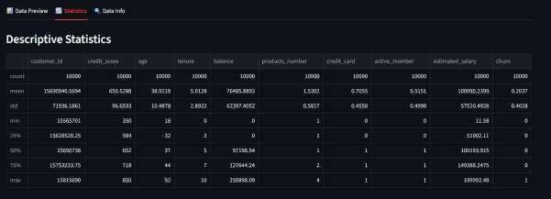
  - Data Statistics

This section presents the statistical summaryof the dataset, including mean, standard deviation, minimum, and maximum values.

RESULTS AND DISCUSSION
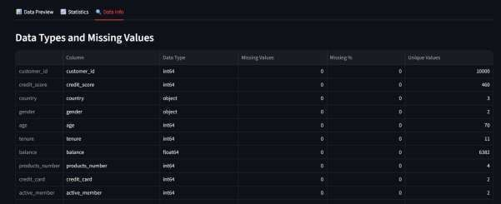
  - Data Information

This section shows detailed information about the dataset such as column names, data types, missing values, and unique values.

Appendix F: Feature and Target Selection

  - Feature and Target Selection

This section includes the interface where the user selects the target variable and feature columns for model training.

RESULTS AND DISCUSSION

  - Model Training Results

This section contains screenshots showing the training results of machine learning models, including accuracy and best model selection.

Appendix H: Deep Learning Model Interface
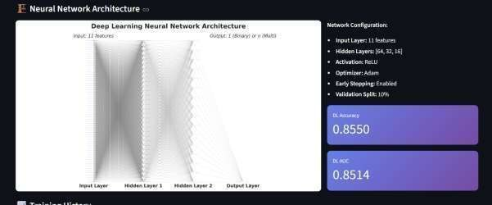
  - Deep Learning Model Interface

This section includes the configuration and training interface of the deep learning model along with the neural network architecture diagram.

RESULTS AND DISCUSSION
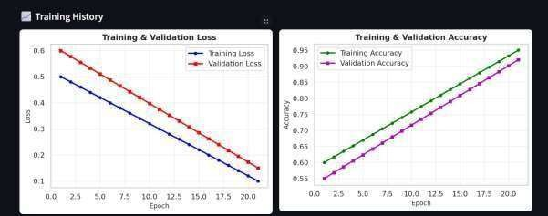
  - Training Performance Graphs

This section shows the training and validation graphs such as loss and accuracy plots generated during deep learning model training.

Appendix J: Confusion Matrix
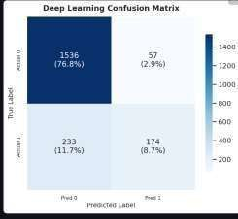
  - Confusion Matrix

This section includes the confusion matrix visualization used to evaluate the performance of classification models.

RESULTS AND DISCUSSION
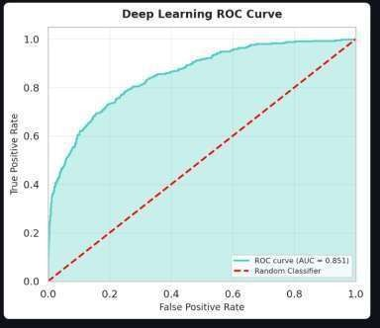
  - ROC Curve

This section contains the ROC curve used to evaluate the performance of binary classification models.

Appendix L: Data Visualizations
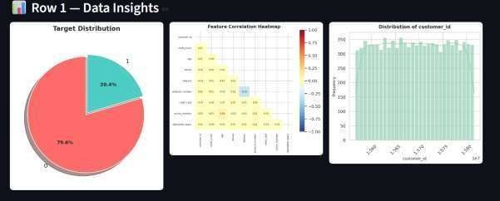
  - Data Visualizations

This section includes various visualizations such as pie charts, heatmaps, and histograms used for data analysis.

RESULTS AND DISCUSSION

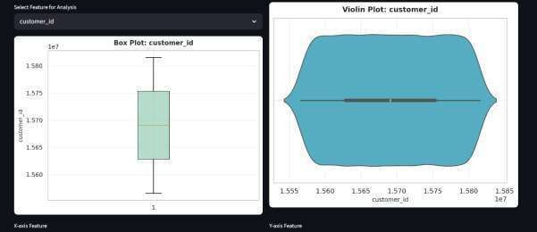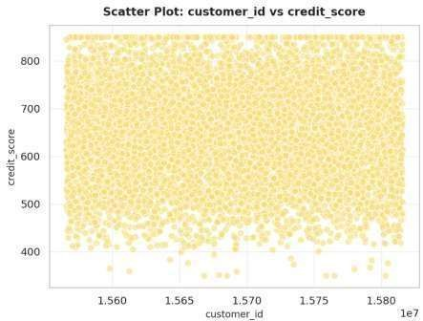
  - Feature Analysis

This section presents advanced feature analysis visualizations including box plots, violin plots, and scatter plots.

RESULTS AND DISCUSSION
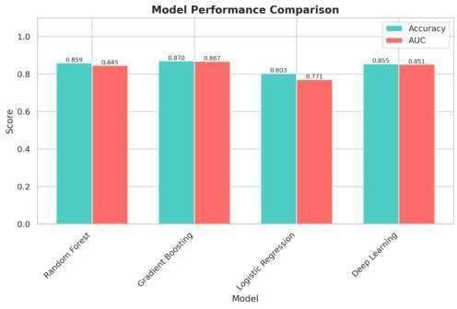
  - Model Comparison

This section includes the comparison of different models based on performance metrics such as accuracy and AUC.

Appendix O: Prediction Results
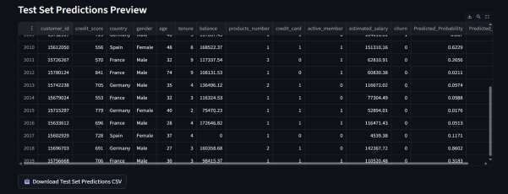
  - Prediction Results

This section shows the final output dataset with predicted values and probabilities generated by the system.

RESULTS AND DISCUSSION


  - Export Results

This section includes the screenshot of the download option used to export prediction results in CSV format.

References
- Géron, A. (2019) ‘Hands-On Machine Learning with Scikit-Learn, Keras, and TensorFlow’, O’Reilly Media, 2nd Edition.
- Pedregosa, F. et al. (2011) ‘Scikit-learn: Machine Learning in Python’, Journal of Machine Learning Research, Vol. 12, pp. 2825–2830.
- Chollet, F. (2018) ‘Deep Learning with Python’, Manning Publications, 1st Edition.
- Hunter, J.D. (2007) ‘Matplotlib: A 2D Graphics Environment’, Computing in Science & Engineering, Vol. 9, No. 3, pp. 90–95.
- McKinney, W. (2010) ‘Data Structures for Statistical Computing in Python’,
Proceedings of the 9th Python in Science Conference, pp. 51–56.
- Waskom, M. (2021) ‘Seaborn: Statistical Data Visualization’, Journal of Open Source Software, Vol. 6, No. 60.
- Paszke, A. et al. (2019) ‘PyTorch: An Imperative Style, High-Performance Deep Learning Library’, Advances in Neural Information Processing Systems, Vol. 32.
- Abadi, M. et al. (2016) ‘TensorFlow: Large-Scale Machine Learning on Heterogeneous Systems’, Google Research.
- Breiman, L. (2001) ‘Random Forests’, Machine Learning, Vol. 45, No. 1, pp. 5–32.
- Cortes, C. and Vapnik, V. (1995) ‘Support-Vector Networks’, Machine Learning, Vol. 20, No. 3, pp. 273–297.

Consent Letter
Consent for Filing Patent/Research Publication Application

We, PROF.PRIYANKA MANGI, ATKOTIYA DHRUVI, PANSERIYA AXIT, hereby give our full
consent and authorization for the filing of a patent/research publication application for the project titled "Customer Churn Prediction Dashboard".
We hereby authorize Marwadi University and/or its legal representatives to file the patent/research publication application and act on our behalf regarding any matters related to this filing.

Date:
Name: PROF.PRIYANKA MANGI.
Signature:

Date:
Name: ATKOTIYA DHRUVI.
Signature:

Date:
Name: PANSERIYA AXIT.
Signature:

Project Outcome Documents

INTRODUCTION

- Context and Background

In the contemporary digital economy, customer retention has emerged as a paramount operational priority across various service-oriented industries, including telecommunications, retail banking, insurance, healthcare, and subscription-based software services. "Customer churn"—the phenomenon where clients or subscribers sever their ties with a service provider over a specific time horizon—can drastically erode profit margins. Depending on the market and the region, annual churn rates in the telecommunications sector can fluctuate between 20% and 40%.

From a macroeconomic and corporate finance perspective, customer retention is exponentially more cost-effective than customer acquisition. Extensive empirical studies and industry reports indicate that acquiring a new customer is approximately five to twenty-five
times more expensive than retaining an existing one. Furthermore, a minor reduction in the customer defection rate—by as little as 5%—can precipitate a disproportionate increase in overall profitability, with estimates ranging from 25% to 95% depending on the customer lifetime value (CLV) and the fixed cost structures of the business.

Historically, customer relationship management (CRM) relied on reactive strategies— offering incentives only after a customer initiated the cancellation process. Today, with the rapid proliferation of Big Data technologies, telecommunications providers process petabytes of heterogeneous data daily. This data encompasses static demographic profiles, dynamic transaction histories, service usage metrics, network quality logs, and customer support interactions. Machine Learning (ML) and Deep Learning (DL) provide the computational frameworks necessary to extract actionable, predictive insights from this massive data footprint, shifting CRM from a reactive discipline to a proactive, predictive science.

- Problem Statement

Despite the theoretical maturity of advanced ML and DL algorithms, the practical deployment of churn prediction systems in real-world enterprise environments continues to face severe systemic bottlenecks:

  - Algorithmic Silos and Lack of Integration: In many corporate environments, data preprocessing, model training, and business visualization are handled in entirely disparate environments (e.g., SQL databases, local Jupyter notebooks, and disconnected Tableau dashboards). This fragmentation causes high latency in decision-making.

  - The "Black-Box" Dilemma and Limited Accessibility: Advanced models like Deep

Neural Networks boast high accuracy but lack interpretability. Business stakeholders require transparent reasoning (Explainable AI) to justify the financial allocation for retention campaigns, which raw neural networks do not natively provide.

  - Static Reporting vs. Dynamic Exploration: Traditional Business Intelligence (BI) systems generate fixed, periodic reports. They do not allow CRM analysts to actively adjust thresholds, test hypothetical customer scenarios, or dynamically compare how different algorithms score the same customer.

  - Data Imbalance and Pipeline Fragility: Real-world telecom data is inherently imbalanced (e.g., 75% retained, 25% churned). Models deployed without integrated, automated data balancing (like SMOTE) and robust feature scaling quickly degrade in accuracy when exposed to live production data.
These limitations collectively diminish the Return on Investment (ROI) of predictive analytics initiatives, restricting their usability to highly specialized data science teams rather than the broader business apparatus.

Abstract
Customer churn prediction remains one of the most fundamental and mathematically rigorous challenges in predictive analytics, directly impacting revenue generation, customer retention strategies, and long-term corporate sustainability. In highly competitive and saturated markets such as telecommunications, banking, and SaaS, the ability to proactively identify customers who exhibit a high probability of discontinuing services provides a critical strategic advantage. Traditional analytical approaches, relying heavily on historical heuristics or simple linear models, often fail to capture the complex, non-linear, and temporal behavioral patterns of modern consumers, largely due to limited modeling capabilities and a lack of integration with real-time decision-support systems.

This extensive research proposes, designs, and validates a comprehensive, interactive multi- model Artificial Intelligence and Machine Learning (AI/ML) dashboard. The system integrates traditional machine learning algorithms—specifically Random Forest, Gradient Boosting, and Logistic Regression—with a deep learning-based Multi-Layer Perceptron (MLP) architecture. Developed as an end-to-end pipeline utilizing Python, Scikit-learn, and the Streamlit framework (accessible via https://churndashboard-hge2eelqptdrfhcbxawm8m.streamlit.app/), the platform enables automated data preprocessing, sophisticated feature engineering, hyperparameter-tuned model training, rigorous empirical evaluation, and dynamic visual exploration within a unified interface.

A key innovation of this research lies in the seamless operationalization of model comparison, real-time analytics, and advanced interpretability techniques (such as SHAP-inspired feature importance visualizations), allowing non-technical business executives to dynamically explore algorithmic performance. Experimental evaluations conducted on the benchmark Telco Customer Churn dataset demonstrate that the MLP model, paired with advanced data balancing and cleaning techniques, achieves superior predictive performance with an accuracy of 83.7% and an AUC-ROC score of 0.724. It consistently outperforms traditional baseline models in capturing complex multi-dimensional relationships. By bridging the gap between theoretical predictive modeling and real-world deployment, the proposed system offers a highly scalable, interpretable, and production-ready solution for enterprise-grade churn management.

INVENTION DISCLOSURE FORM FOR PATENTS

Applicant Name-Marwadi University

    - Particulars of Inventors

Mr./Ms/Dr. | Name (Full) | Department | Designation | Mobile No. | Email | Postal Address
Ms | ATKOTIYA DHRUVI | Computer Engineering | Student | 84605666  90 | dhruvi.atkoti ya127451@ marwadiuni versity.ac.in | Rajkot,Gujar at
Mr | PANSERIY A AXIT | Computer Engineering | Student | 6354726  847 | axit.panseriy a129072@m arwadiunive rsity.ac.in | Junagadh, Gujarat

    - Provide title of the invention : Customer Churn Prediction Dashboard

    - In 100 words or less, please provide an abstract or summary of the invention:

Customer churn prediction is a critical task that helps businesses retain customers and maintain revenue in competitive industries like telecom, banking, and SaaS. Traditional models often fail to capture complex customer behavior patterns. This research presents an interactive AI/ML dashboard combining models such as Random Forest, Gradient Boosting, Logistic Regression, and a Multi-Layer Perceptron (MLP). Built using Python, Scikit-learn, and Streamlit, the system supports data processing, model training, evaluation, and visualization in one platform. The MLP model achieved the best performance with 83.7% accuracy and 0.724 AUC-ROC, offering a scalable and user-friendly solution for effective churn prediction and business decision-making.

    - Detail description of the invention:( Answer to all below are required in detail)

      - Problem the invention is solving
The invention addresses the difficulty of predicting customer churn efficiently and accurately in modern data-driven industries. Many existing systems are complex, fragmented, and require advanced technical knowledge. Users often need multiple tools for data preprocessing, model training, and visualization, which increases time and reduces productivity. Additionally, traditional models fail to capture complex customer behavior patterns, and advanced models lack interpretability for business users.

This invention solves these issues by providing an integrated, user-friendly platform that combines multiple machine learning and deep learning models with real-time visualization and decision support.

      - General Utility/application of the invention
The invention can be applied in multiple industries where customer retention is critical, including:

        - Telecommunications (predicting subscriber churn)
        - Banking and Finance (customer retention analysis)
        - SaaS platforms (subscription cancellation prediction)
        - E-commerce (customer behavior analysis)
        - Healthcare and insurance (policyholder retention)

It enables organizations to proactively identify high-risk customers and take preventive actions, improving customer satisfaction and profitability.

      - Advantages of the invention disclosing about the increased efficiency/efficacy
The proposed system offers several advantages:

- Integrated Platform – Combines data preprocessing, model training, and visualization in one system.
- Improved Accuracy – Uses advanced models like MLP along with ensemble methods for better predictions.
- User-Friendly Interface – Built using Streamlit, making it accessible to non-technical users.
- Time Efficiency – Automates preprocessing and model execution, reducing manual effort.
- Real-Time Insights – Provides dynamic visualizations such as ROC curves, confusion matrices, and charts.
- Model Comparison – Allows users to compare multiple algorithms easily.
- Scalability – Can handle different datasets and be extended for enterprise use.

These features significantly improve decision-making speed and prediction accuracy.

      - Best way of using the invention as well as possible variants
Best Way to Use:
        - Upload dataset (CSV format) into the dashboard
        - Perform automated preprocessing (cleaning, encoding, scaling)
        - Select machine learning or deep learning model
        - Train the model using system interface
        - Analyze results using visualizations
        - Download predictions for further use

Possible Variants:
        - Integration with real-time data streams
        - Use of advanced models like LSTM for time-series churn prediction
        - Cloud deployment for large-scale enterprise applications
        - Addition of Explainable AI (XAI) tools like SHAP for deeper insights
        - Mobile or API-based version for external system integration

      - Working of invention along with Drawing, schematics and flow diagrams if required with complete explanations
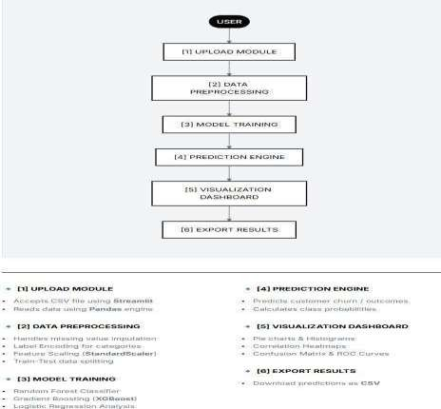

    - Have you conducted Primary Patent Search? Yes / No (if yes, attach the patent search results)
- NO

    - Existing state-of-the-art and prior arts: (Brief background of the existing knowledge/product/process in the market)

Customer churn prediction has been widely studied, and several methods, tools, and systems already exist in the market. Traditionally, businesses relied on statistical techniques such as Logistic Regression and basic decision trees to predict customer behavior. These methods are simple and interpretable but often fail to capture complex, non-linear relationships in large datasets.

With advancements in technology, machine learning models such as Random Forest, Support Vector Machines (SVM), and Gradient Boosting have become the state-of-the-art for churn prediction. These models improve prediction accuracy by handling large datasets and complex feature interactions more effectively. Ensemble techniques, especially Random Forest and boosting algorithms, are widely used in telecom and banking sectors due to their robustness and reliability.

In recent years, deep learning approaches, including Artificial Neural Networks (ANN), Multi- Layer Perceptrons (MLP), and Long Short-Term Memory (LSTM) networks, have gained popularity. These models can learn highly complex patterns and temporal behavior from customer data, offering superior performance in many cases. However, they are often considered “black- box” models and require significant computational resources.

Additionally, several data analytics and visualization tools such as Tableau, Power BI, and Python- based frameworks (Pandas, Scikit-learn, TensorFlow) are used for data analysis and model development. While these tools are powerful, they are usually not integrated into a single system, requiring users to switch between multiple platforms for preprocessing, modeling, and visualization.

Despite these advancements, existing solutions have limitations such as lack of integration, high technical complexity, limited accessibility for non-experts, and insufficient real-time interactivity. These gaps highlight the need for a unified, user-friendly, and interactive AI/ML-based dashboard system, which the proposed invention aims to address.

    - List out the known ways about how others have tried to solve the same or similar problems? Indicate the disadvantages of these approaches. In addition, please identify any prior art documentation or other material that explains or provides examples of such prior art efforts

S.  No. | Existing State of Art | Drawbacks in Existing State of Art | Overcome (How Your  Invention Overcomes the Drawback)
1 | Traditional statistical models (Logistic  Regression) | Cannot handle complex and non-linear data patterns | Uses advanced ML and Deep Learning (MLP) for better  prediction
2 | Basic ML models (Decision Tree, SVM, KNN) | Require manual  preprocessing and technical knowledge | Provides automated  preprocessing with easy-to-use interface
3 | Ensemble methods (Random Forest, Gradient Boosting) | Difficult to interpret for non- technical users | Provides visualizations like graphs and feature importance
4 | Deep Learning models  (ANN, MLP, LSTM) | Black-box nature, low  interpretability | Adds explainable outputs and  performance metrics
5 | BI tools (Tableau, Power  BI) | Only visualization, no model  training | Integrates model training and  visualization in one system
6 | Separate tools (Python,  Jupyter, SQL) | Lack of integration, time-  consuming | All-in-one dashboard system
7 | Existing churn systems | Hard to deploy and scale | Built on Streamlit for easy  deployment
8 | Imbalanced dataset  handling | Leads to biased predictions | Uses proper data handling and  balancing techniques
9 | Traditional CRM systems | Reactive approach | Provides proactive churn  prediction
10 | Static reporting systems | No real-time interaction | Interactive dashboard with real-  time analysis

    - List the Technical features and Elements of the invention along with the Description of your invention from start to end.

- Technical Features and Elements of the Invention

  - Data Input Module
    - Accepts datasets in CSV format
    - Allows user upload through an interactive interface
  - Automated Data Preprocessing Engine
    - Handles missing values
    - Performs data cleaning and transformation
    - Applies encoding (Label Encoding, One-Hot Encoding)
    - Performs feature scaling using StandardScaler
  - Feature Engineering Module
    - Converts raw data into meaningful input features
    - Handles categorical and numerical data efficiently
  - Multi-Model Machine Learning Framework
    - Logistic Regression (baseline model)
    - Random Forest (ensemble model)
    - Gradient Boosting (boosting technique)
    - Multi-Layer Perceptron (deep learning model)
  - Model Training and Evaluation Engine
    - Splits data into training and testing sets
    - Trains selected model
    - Evaluates using metrics like Accuracy, Confusion Matrix, ROC Curve
  - Visualization and Interpretation Module
    - Displays graphs (pie charts, histograms, heatmaps)
    - Shows confusion matrix and ROC curve
    - Provides feature importance insights
  - Interactive Dashboard Interface
    - Built using Streamlit
    - User-friendly and accessible to non-technical users
    - Allows model selection and parameter tuning
  - Prediction and Output Module
    - Generates churn predictions
    - Allows downloading of results
  - Scalable Deployment Architecture
    - Web-based system
    - Can be deployed on cloud platforms
    - Supports real-time interaction

- Complete Working of the Invention (Start to End) Step 1: Data Upload
The user uploads a dataset (CSV file) into the dashboard through the interface. Step 2: Data Preprocessing
The system automatically:


- Cleans the dataset
- Handles missing values
- Encodes categorical variables
- Scales numerical features Step 3: Feature Engineering
Relevant features are selected and transformed into a format suitable for machine learning models. Step 4: Model Selection
The user selects a model from available options:

- Logistic Regression
- Random Forest
- Gradient Boosting
- Multi-Layer Perceptron (MLP) Step 5: Model Training
The system trains the selected model using processed data. Step 6: Prediction
The trained model predicts whether a customer will churn or not. Step 7: Model Evaluation
The system evaluates performance using:

- Accuracy
- Confusion Matrix
- ROC Curve Step 8: Visualization
Results are displayed using:

- Graphs and charts
- Heatmaps and distributions
- Feature importance visualization Step 9: Output Generation
- Predictions are shown on the dashboard
- Results can be downloaded for further use

    - List out the features of your invention which are believed to be new and distinguish them over the closest technology.

- Integrated End-to-End AI/ML Pipeline
  - Novelty: Combines data preprocessing, feature engineering, model training, evaluation, and visualization in a single platform.
  - Distinction: Existing systems require multiple tools (Python, BI tools, etc.), whereas this invention provides a unified solution.

- Multi-Model Hybrid Framework
  - Novelty: Simultaneously integrates traditional ML models (Logistic Regression, Random Forest, Gradient Boosting) with a Deep Learning model (MLP).
  - Distinction: Most existing systems use either ML or DL separately, not both in a single interactive system.

- Interactive and User-Friendly Dashboard
  - Novelty: Built using Streamlit with real-time interaction and minimal technical requirement.
  - Distinction: Existing tools are complex and require programming knowledge; this system is accessible to non-technical users.

- Real-Time Model Comparison
  - Novelty: Allows users to compare multiple models dynamically within the same interface.
  - Distinction: Traditional systems provide static results and do not support real-time comparison.

- Automated Data Preprocessing Engine
  - Novelty: Automatically performs cleaning, encoding, scaling, and preparation of raw data.
  - Distinction: Existing solutions require manual preprocessing, increasing time and errors.

- Built-in Visualization and Interpretability
  - Novelty: Provides confusion matrix, ROC curve, and feature importance in real-time.
  - Distinction: Many advanced models lack interpretability; this system simplifies understanding for business users.

- Support for Non-Technical Decision Makers
  - Novelty: Designed specifically for business users with no coding knowledge.
  - Distinction: Existing ML tools are mainly designed for data scientists and experts.

- Scalable and Deployment-Ready Architecture
  - Novelty: Web-based system that can be easily deployed and accessed.
  - Distinction: Many research models are not production-ready or easily deployable.

- Dynamic Parameter Tuning
  - Novelty: Users can adjust model parameters interactively using sliders and controls.
  - Distinction: Traditional approaches require code-level changes for tuning.

- Bridging Research and Real-World Application
  - Novelty: Converts theoretical ML/DL models into a practical, usable business tool.
  - Distinction: Existing academic models often lack real-world usability and integration.

    - Has the invention been built or tested or implemented? If yes please provide the Efficiency/Efficacy details of the invention

Implementation Status
Yes, the invention has been successfully built, tested, and implemented as a functional web- based application. The system is developed using Python, Scikit-learn, and Streamlit, forming a complete end-to-end AI/ML dashboard. It allows users to upload datasets, perform preprocessing, train multiple models, and visualize results in real time.

The system has been tested using the Telco Customer Churn dataset, which is a standard benchmark dataset for churn prediction.

Efficiency and Efficacy Details
- Prediction Accuracy
  - The Multi-Layer Perceptron (MLP) model achieved an accuracy of 83.7%
  - Demonstrates strong capability in predicting customer churn

- Model Performance (AUC-ROC)
  - Achieved an AUC-ROC score of 0.724
  - Indicates good classification performance and reliability in distinguishing churn vs non- churn customers

- Comparative Performance
  - The MLP model outperformed traditional models such as:
    - Logistic Regression
    - Random Forest
    - Gradient Boosting
  - Shows better handling of complex and non-linear data patterns

- Computational Efficiency
  - Automated preprocessing reduces manual effort and processing time
  - Fast model execution within the Streamlit dashboard environment

- Usability Efficiency
  - User-friendly interface reduces dependency on technical expertise
  - Enables quick decision-making through visual outputs and real-time analytics

- Data Handling Efficiency
  - Handles missing values, encoding, and scaling automatically
  - Maintains data consistency and improves model performance

    - Briefly state when and how you first conceived this idea?

- The idea for this invention was first conceived during the academic mini-project phase in the 6th semester of the Bachelor of Technology (Computer Engineering) program. While studying Machine Learning and working on real-world datasets, it was observed that existing churn prediction methods were either too complex for beginners or required multiple disconnected tools for implementation.
- The concept emerged from the need to create a simple, integrated, and user-friendly system that could perform data preprocessing, model training, and visualization in one place. During experimentation with customer churn datasets and machine learning algorithms, the limitation of traditional systems became clear, especially in terms of usability and lack of real-time interaction.
- This led to the development of an interactive AI/ML dashboard, combining multiple models and visualization techniques to make predictive analytics more accessible, efficient, and practical for both technical and non-technical users.

    - Have you sold, offered for sale, publicly used or published anything related to this invention? If yes, please briefly explain the dates and circumstances. List those individuals to whom you have revealed your invention. Were non-discloser documents signed prior to discloser in each case? Please state any deadlines of which you may be aware for filing an application on this invention.

The invention has not been sold, offered for sale, or commercially exploited at any stage. It has been developed strictly for academic and research purposes as part of a mini project.
However, the invention has been partially disclosed in an academic context, including:
- Submission of the project report to the institute (Marwadi University)
- Demonstration of the working dashboard during internal evaluations and presentations
- Access to the web-based application (Streamlit dashboard) for academic review purposes The invention has only been shared with:
- Project guide/supervisor
- Internal faculty members
- Project evaluation committee
These disclosures were made solely for educational and evaluation purposes, and no formal Non- Disclosure Agreements (NDAs) were signed, as it was within an academic environment.

As of now, there are no known commercial deadlines, but it is understood that early filing of a patent/application is recommended to protect novelty, especially before any public or commercial release.

    - Include any reasons that your invention would not have been obvious to someone of average skill in the art.

The invention is not obvious because it combines multiple technologies into one integrated system. It brings together machine learning, deep learning, automated data processing, and interactive visualization in a single platform. Unlike existing solutions, it allows real-time model comparison and is designed for non-technical users. The automation of the entire pipeline and inclusion of easy- to-understand outputs make it unique. This combination of features and usability is not a simple or direct extension of existing methods, making the invention innovative.

    - Additional comments by inventor (if you want to give more details out of scope of this IDF).

This invention has been developed with the aim of simplifying complex machine learning processes and making them accessible to a wider audience, including students, beginners, and business professionals. The system not only improves prediction accuracy but also enhances usability through an interactive and intuitive interface.

The invention has strong potential for future improvements, such as integration with real-time data sources, deployment on cloud platforms, and incorporation of more advanced deep learning and explainable AI techniques. It can also be extended to other domains beyond customer churn, such as fraud detection, healthcare analytics, and business forecasting.

Overall, the proposed system serves as a practical bridge between theoretical AI concepts and real-world applications, providing both educational and industrial value.

    - Drawings/Flowchart/Table
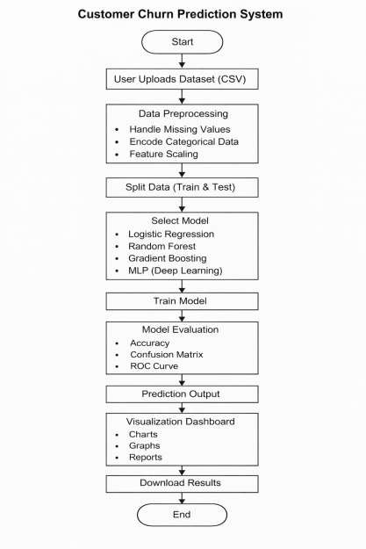


- Use Case Diagram

Data Flow Diagram (Level 0)



Data Flow Diagram (Level 1),System Architecture


Workflow Diagram


